The Little Book of Caring Ways

Ways to use kindness for better mental health in Scotland

Easy Read version

The Search for Happiness
We all want to be happy. Happiness makes us feel good. It makes our lives better.
Being happy can make our hearts healthier. It helps us cope with stress and can help us live longer.
We do not know exactly how being happier leads to better health. We want to find out more about it.
Some doctors think that there are three kinds of happiness:

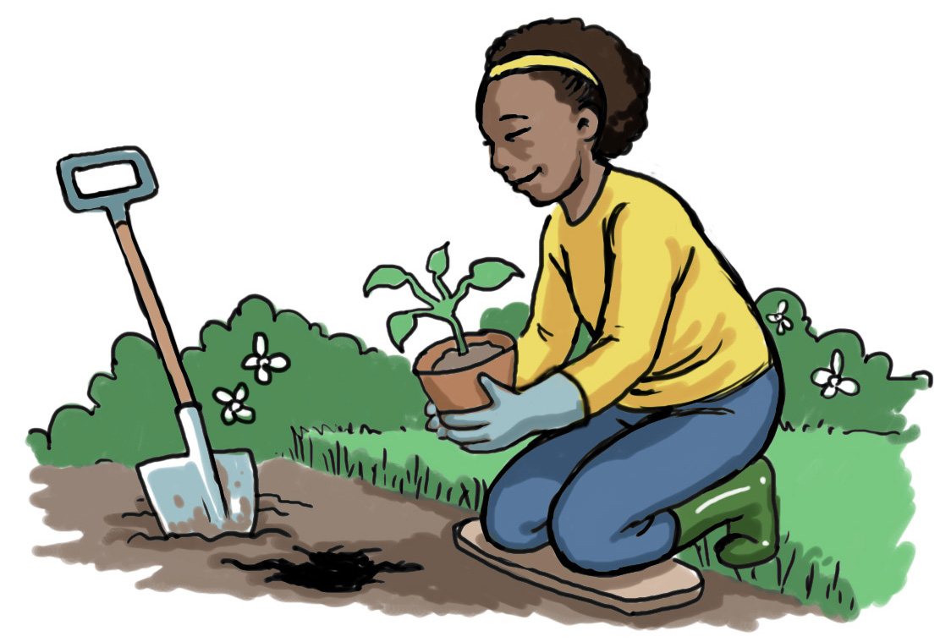
Good life - using skills and talents to make our lives better, like having hobbies.

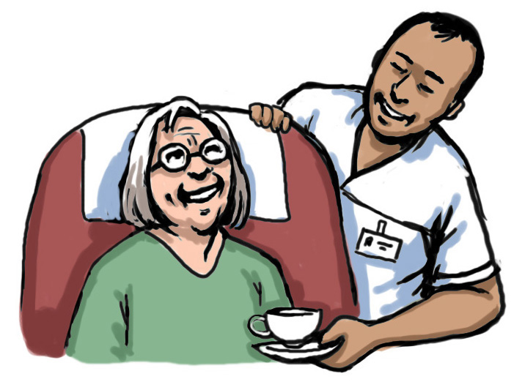
Meaningful life - feeling good because we are doing good for other people.

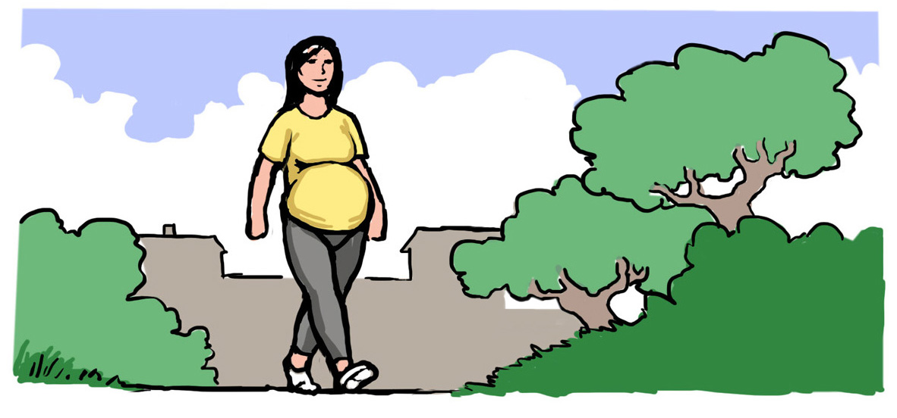
Pleasant life - enjoying daily pleasures like a walk in
the park.

The happiest people are the ones who have all three kinds of happiness. We think this means that they key to happiness is not just how we feel in ourselves. It is also about how we deal with other people.
You matter. We care.

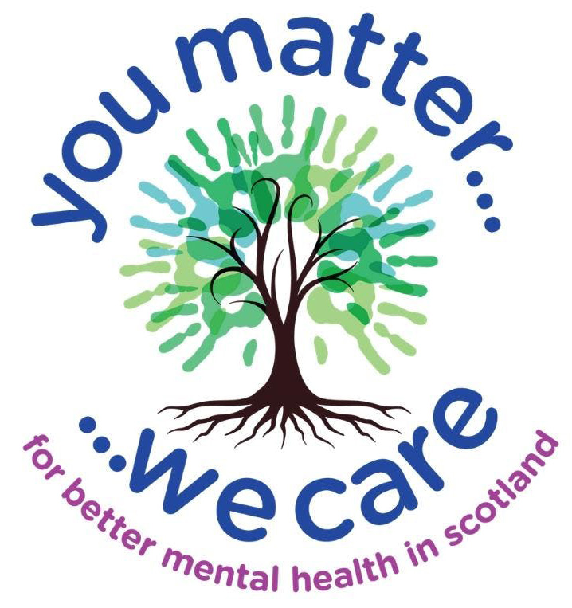
The ‘You Matter, We Care’ campaign by Breathing Space, Scotland’s mental health phone service, is about using kindness and positive relationships for better mental wellbeing.
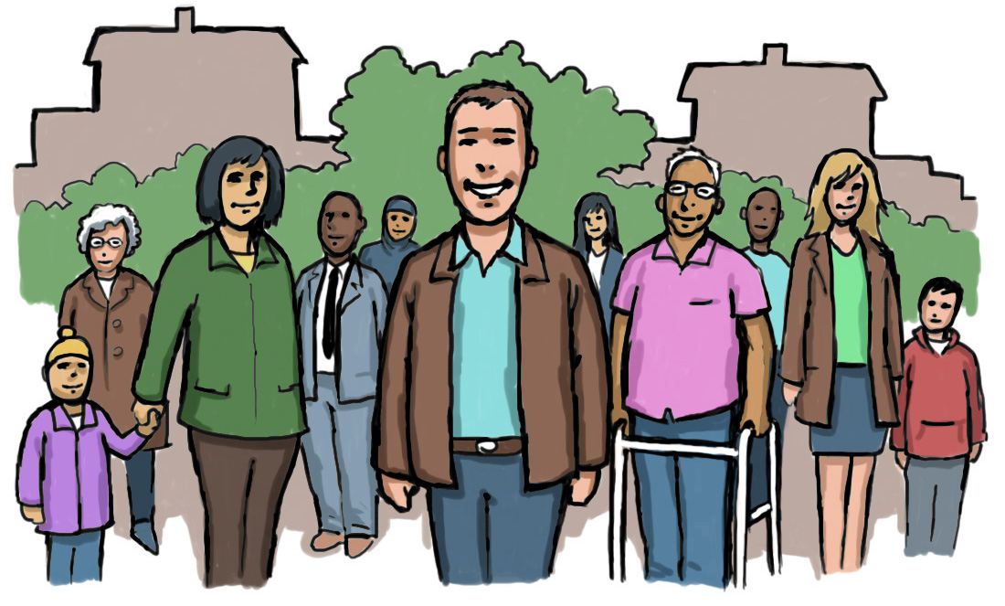
Mental wellbeing is linked to our relationships with family, friends and the groups we are part of.
We want to tackle social isolation and loneliness by building stronger links in Scotland .
Caring relationships matter in difficult times. This booklet looks at fours ways to build these relationships:

Compassion
Appreciation
Random acts of kindness
Empowerment
The more closely connected we feel to the people in our lives, the happier we are.

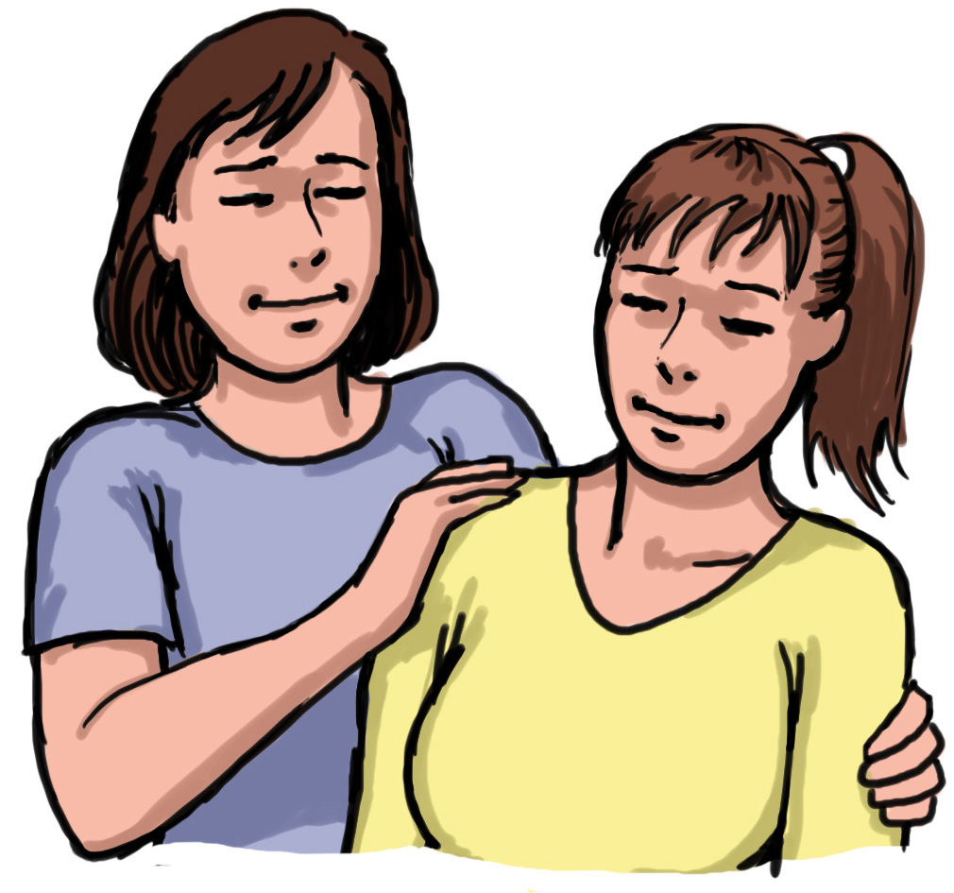
Compassion
Compassion is seeing someone is in emotional pain. We care about how they feel and help them. Compassion is a natural feeling that helps us to survive. Compassion can help us feel happy and calm, so we are able to make the right decisions.

Growing Compassion
Be kind to yourself
Compassion for others starts with being kind to yourself. When you can forgive yourself, it is easier to forgive others.

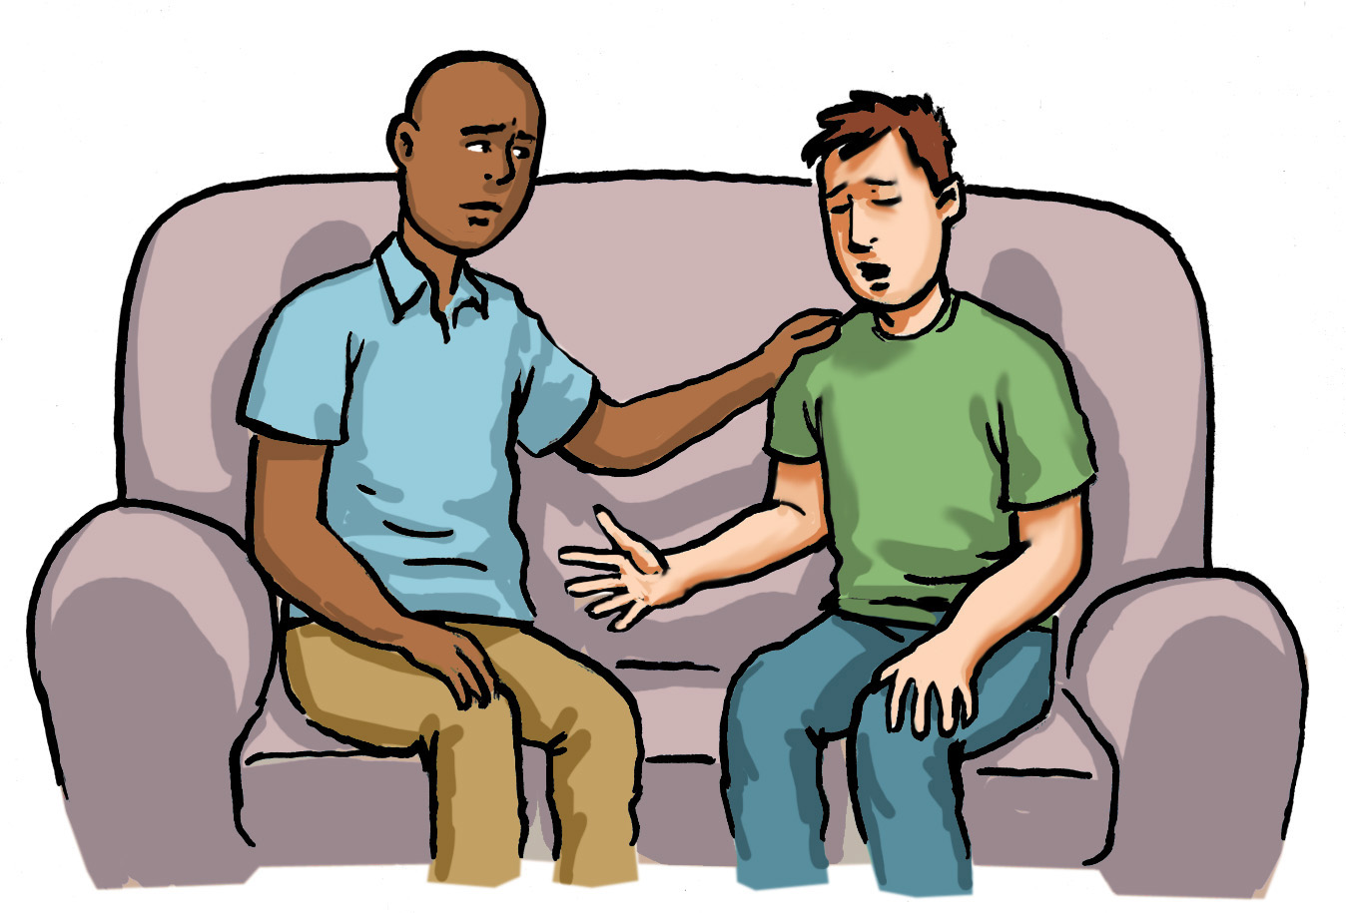
Friends and family
Being with someone when they are hurting can make all the difference. You learn to be aware and with the person who is suffering, without wanting to solve the problem.

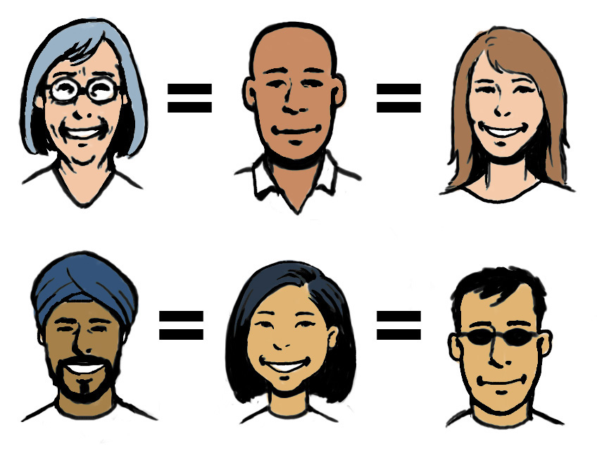
Empathy to strangers
Compassion is easiest to feel when you have something in common with someone else. Learning to understand what we have in common brings us closer together.

Setting healthy limits
It is okay:

...to make mistakes
...to have bad days
...to be less than perfect
...to do what is best for you
...to be yourself
It can sometimes be hard to say no or that you do not agree.

Knowing if the things we do will make us feel stressed, hurt or angry is not always easy.
To be compassionate we need to set healthy limits to protect and care for ourselves.
You do not always have to explain the limit to the other person. Setting the limit is the important part.

7 Top Tips
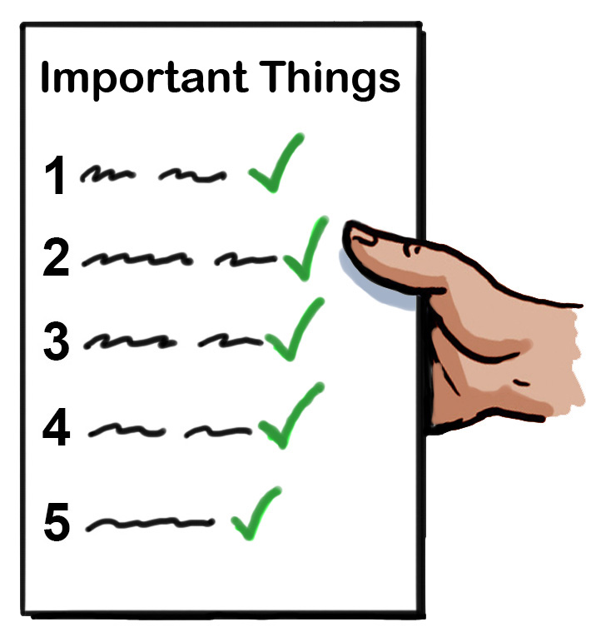
Compassion
1. Learn what is important to you. This will help you make decisions that give you the experiences you want.

2. Take responsibility for yourself. Know what needs to be done for yourself. Remember that whatever you say goes.

3. Develop a healthy self-respect. Only you can decide who you are. Expect others to respect you.

4. Pay attention to warning signs. Keep away from anyone who is invading your space for their own reasons.

5. Do not try to fix people. Fixing others is selfish. It can be a way to get attention or feel better about yourself.

6. You are in charge. You can change your mind and walk away at any time.

7. Separate yourself from others. Understand that your limits are different to others. Respect other people’s limits without changing your own.

You can be a good person with a kind heart
and still say no.

Appreciation

We have found that giving thanks can make you happier. When we feel grateful people have more positive emotions. They enjoy experiences, deal with hard times and keep healthy relationships. All of this makes them feel happier.

We want to increase these feelings.

Encouraging appreciation

Enjoy the little things
Getting into the habit of feeling grateful could be as simple as enjoying nice weather.

Keeping a journal
Writing down positive thoughts can help keep your mind on them and stop you thinking about bad things.

Spending time with loved ones
Supporting those around you that you care about can help.

Say ‘thank you’
Not only can it brighten someone’s day, it can make you happier too.

Be ‘in the moment’
Think of five things you are grateful for each day. Train your brain towards being ‘in the moment’ and feeling thankful. It then comes more easily.

Improve happiness levels
Activities like exercise can help to lift your mood and put you in the mindset of being thankful.
Think of challenges
Think about difficult situations. They can help you remember what to be thankful for.
Giving back
Volunteering and giving back to your community is good in lots of ways.

Lasting positive impact
Gratitude is being thankful. It can have a lasting positive impact if it is part of our daily lives.

The more we say ‘thank you’, the better we feel and the more grateful we are likely to be.

Random acts of kindness
Kindness makes strong connections
between people.

Being connected makes us feel Good. It make us do good things, which is good for everyone.

Measuring kindness in Scotland
People in Scotland say they experience more
Kindness than any other part of the UK and Ireland. This is both giving it and taking it.
People in Scotland also experience more kindness when using public services.

The importance of kindness to wellbeing

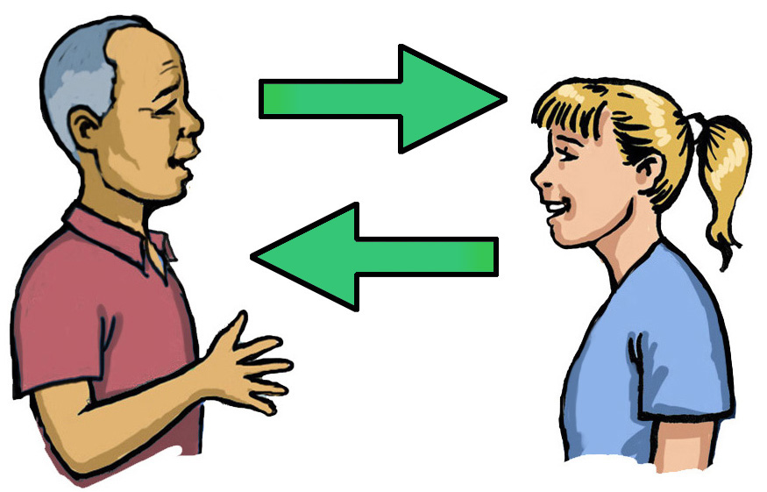
Random acts of kindness are good for the person you are kind to and good for you.

Helping others helps to relieve pain, stress, anxiety and depression.
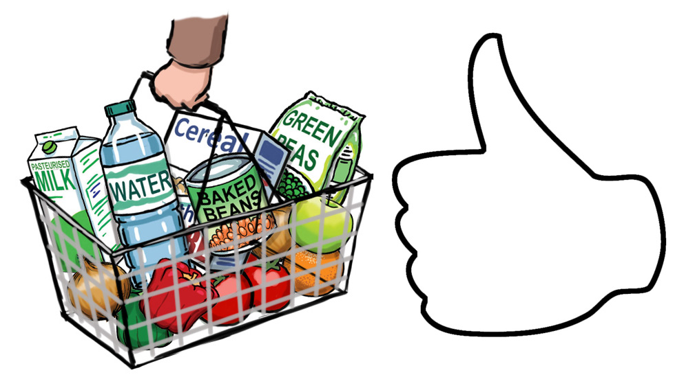
You could send someone a text who might need it, go shopping for a vulnerable neighbour or check in with a friend. These are all ways of playing your part in your community.
Empowerment

Empowering yourself

Self-kindness – tell yourself in a warm and supportive way that it is better not to judge other people or ourselves.

We are all in this together - we wrongly believe everyone else has perfect lives. You are not alone if you fail. Knowing that personal failures are what makes us human can help us feel connected to others.

Mindfulness - if you are ignoring pain you cannot
give yourself compassion. It’s OK to say, ‘this is really difficult’, without lots of bad feelings.

can help us feel more connected to others.

Using mindfulness in everyday life

Mindfulness is a way of slowing down, standing back from our thoughts and noticing the world around us. It can help us to stop bad behaviour and find better ways to deal with things.

How to be more mindful

1. Notice the everyday. Notice the things around you and how you feel.

2. Keep it regular. Pick a regular time to be more aware of your environment.

3.Try something new. Try things like going somewhere new to help you notice the world in a new way.

4. Watch your thoughts – you can let some thoughts come and go without having to do anything about them.

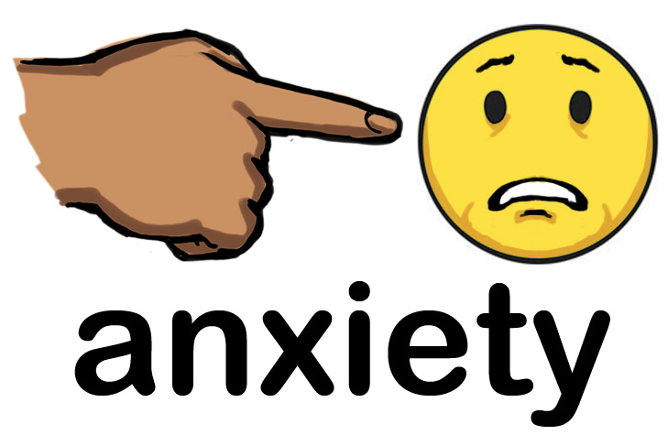
5. Name thoughts and feelings. Get to know your feelings. It can help to know when they happen.
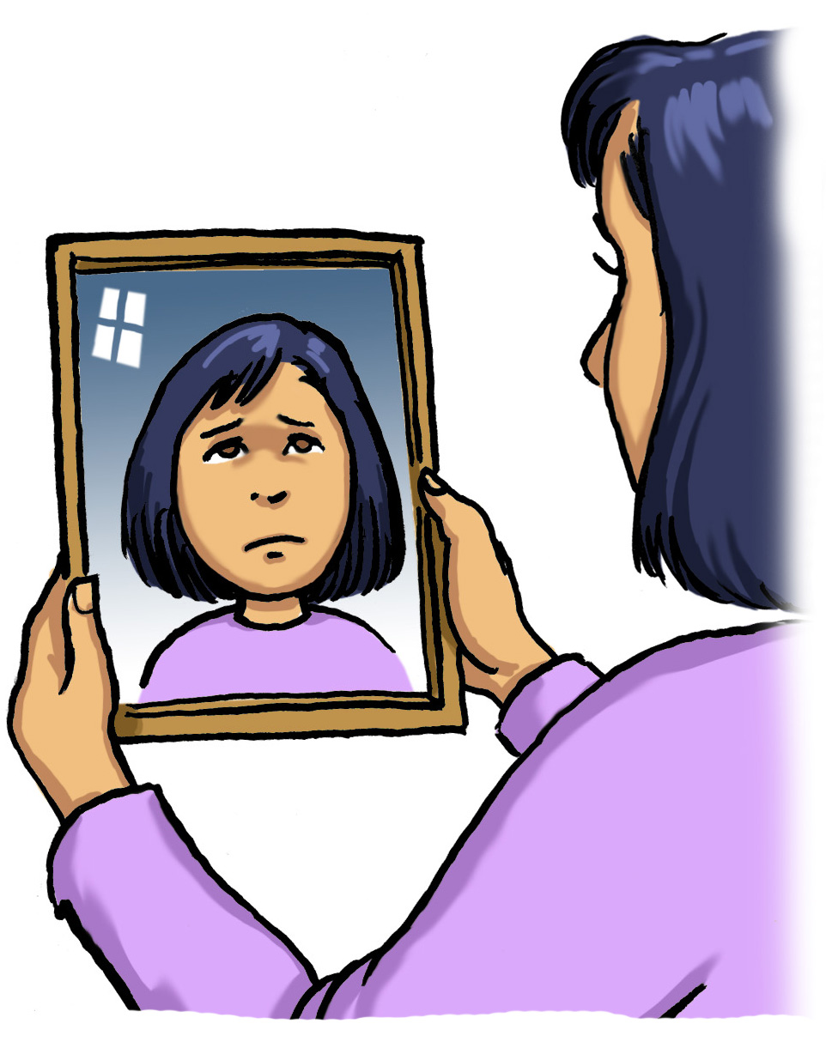

6. Free yourself from the past and future. Take a mindful approach if you find yourself thinking about past or future problems.

way of motivating ourselves.
Difficult times

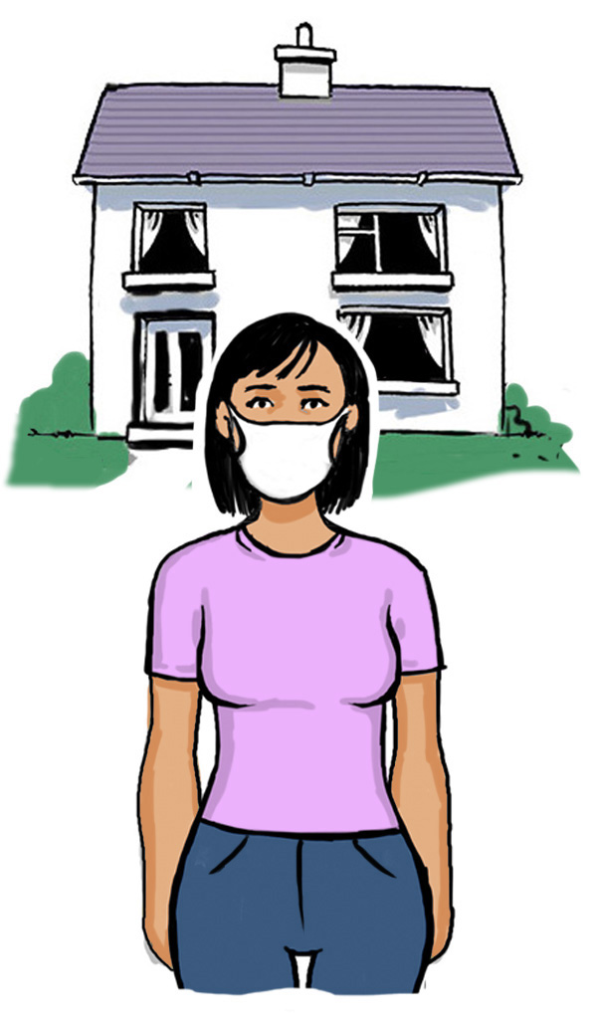
Even when times are tough, we can all choose to be kind.

Kindness is a big part of being strong. Without kindness and support, dealing with difficult things is even harder.

The Scottish Recovery Network held online conversations on staying well during and after
the COVID-19 lockdown.

Many people said they were able to use their experiences of mental health crisis and recovery to
support their wellbeing.

It is a tough to accept when we are going through a time when there are so many things out of our own control.

Circles of Control

The activity is from the British Red Cross. It can help us to be strong and kind.

Think about things in your life which you can and cannot control.

In the outside circle - write down the things you are worried about but cannot control.
In the middle circle - write down the things you can control.
Pick your biggest worry and think of a plan for how to deal with it. Work on one problem at a time.
Remember!!! Being kind to yourself. It is as important as being kind to others.
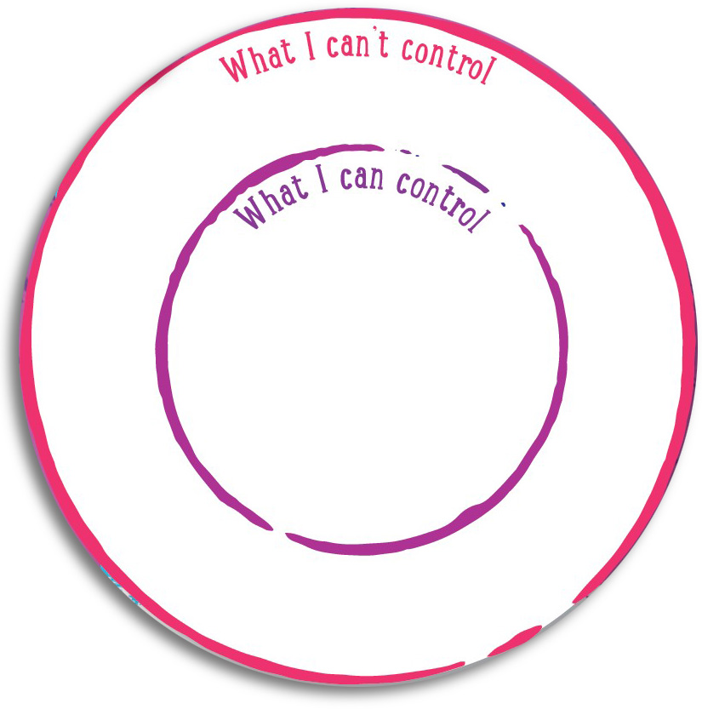

Breathing Space provides:
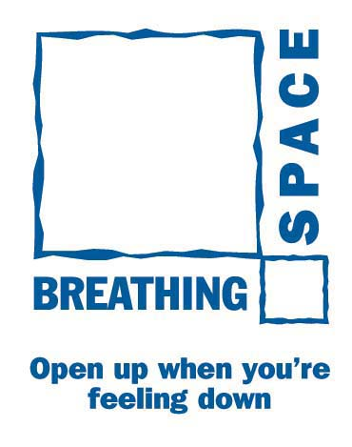
- an alternative and easily accessible service
- help at an early stage in order to stop problems getting worse
- understanding and advice through active listening
- hope when there is not any
- direction for those who do not know where to seek help.

You are not alone - talking about how you feel is a positive first step in getting help.

To take some Breathing Space, call 0800 83 85 87.

